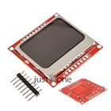**84x48 Nokia LCD Module Blue Backlight Adapter PCB Nokia 5110 LCD For Arduino**

Product Details: Nokia 5110 LCD Module

Condition: New

Positioning hole for four corners

Provide two row terminals, red screen

Interface: serial SPI

Color as pictures

PLS NOTE that due to lighting effects, monitor's brightness/ contrass settings ect, there could be some slight differences in the color tone of the pictures and the actual item!

Package Included:

1 x Nokia 5110 LCD Module